# TAX INVOICE

**Original for recipient**

# VKC/24-25/2

## V K Control System Private Limited

302, Somnath Apartment Surabhi-Layout, Tapovan Road, Camp, Amravati, MH (27) 444602, IN

+919168696090

[sales@vkcontrol.com](mailto:sales@vkcontrol.com)

**GSTIN:** 27AAFCV2449G1Z7 **PAN:** ABCTT8710P **FSSAI No.:** 123

**D.L. No.:** 456 **Website:** [www.sleekbill.in](http://www.sleekbill.in/) **Contact Name:** Vicky Kalbande

**Bill to**

## ADDIRE ENGINEERS

Issue Date: Due Date: Place of Supply:

Amount Due: ₹4,295.00

**Ship to**

### KAVITA KRISHNA PATHARE (B2B)

28 / 11 / 2024

05 / 12 / 2024

### MH (27)

KAVITA KRISHNA PATHARE F-28, Zojwala Complex, Behind Ramdev Hotel, Agra Road, Kalyan-

KAVITA KRISHNA PATHARE (B2B)

F-28, Zojwala Complex, Behind Ramdev Hotel, Agra Road, Kalyan-

Dombivali, MH (27) 421301, IN

[pradeep@addireengineers.com](mailto:pradeep@addireengineers.com) 9987851729 **GSTIN:** 27HMIGA8380S8Z0

27CUWPP5036K1ZS

Dombivali, MH (27) 421301, IN

**Account Holder Name: Sleek Bill for India Bank Name: ICICI LTD**

**Account Number: 69485165263 Branch Name: Pune**

**IFSC Code: SBIN0004881**

**PAYMENT QR CODE**

**UPI ID:**

**sleekbill123@okicici**

**Terms & Conditions**

*Thanks for Business!*

**Total @3% @5% @12%**

**Total Taxable Value ₹4,000.00**

|  |  |  |  |  |  |  |  |  |
| --- | --- | --- | --- | --- | --- | --- | --- | --- |
| **S.No** | **Item Description** | **HSN/SAC** | **Qty**  **UoM** | **Unit Price**  **(₹)** | **Taxable Value**  **(₹)** | **CGST**  **(₹)** | **SGST**  **(₹)** | **Amount**  **(₹)** |
| **1** | **(XB7EV04MPN) RED** | **85318000** | **5.00** | **100.00** | **500.00** | **7.50** | **7.50** | **515.00** |
|  | **INDICATION LAMP** |  | **NOS** |  |  | **1.5%** | **1.5%** |  |
|  | **XB7EV04MPN Red Pilot Lights** |  |  |  |  |  |  |  |
|  | **Make - Schneider, 230 V Ac ;** |  |  |  |  |  |  |  |
|  | **Lighting Type. LED** |  |  |  |  |  |  |  |
| **2** | **0028303 UNITRONIC LIYY** | **85444920** | **2.00** | **1,000.00** | **2,000.00** | **50.00** | **50.00** | **2,100.00** |
|  | **3X0.25** |  | **M** |  |  | **2.5%** | **2.5%** |  |
|  | **3x0.25mm2, unshielded; 500V** |  |  |  |  |  |  |  |
| **3** | **Airwick Dispenser** | **39269099** | **3.00** | **500.00** | **1,500.00** | **90.00** | **90.00** | **1,680.00** |
|  | **room air fresheners** |  | **PCS** |  |  | **6%** | **6%** |  |
|  | | | | | **500.00** | **7.50** | **7.50** | **515.00** |
| **2,000.00** | **50.00** | **50.00** | **2,100.00** |
| **1,500.00** | **90.00** | **90.00** | **1,680.00** |

**Total Tax Amount ₹295.00**

**Total Value (in gure) ₹4,295**

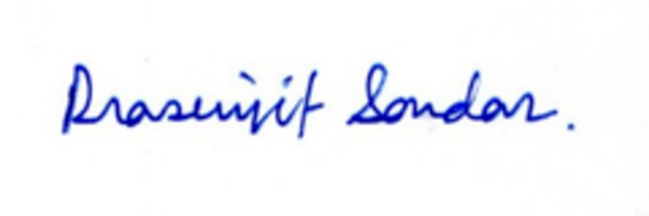**Total Value (in words) ₹ Four Thousand Two Hundred Ninety- ve Only**